**PERTH MODERN SCHOOL**

**Tick your teacher**

* Ms Cheng
* Dr. Pearce
* Ms Sindel
* Ms Rimando



**YR11 MATHEMATICS SPECIALIST – 2018**

**TEST 3 – Vectors**

**NAME: _____________________________________ DATE: 14/05/2108 Mark:________**

***Calculator Assumed Time: 40 minutes Mark: 35 marks***

**Question 1 (4 marks)**

If $a= -2i+5j$ and $b=xi-2j$ are two vectors. Find:

1. $x$ if $a$ and $b$ are parallel. (2 marks)
2. $x$ if $a$ and $b$ are perpendicular. (2 marks)

**Question 2 (3 marks)**

Consider the points $A\left(-1,6\right), B\left(-3,-2\right)$ and $C (7, 3)$. Calculate the angle between $BA$ and $BC.$

**Question 3 (4 marks)**

1. Find the scalar projection in the direction of o of a vector of magnitude 20 in the direction of 163o.

(2 marks)

1. Let $a=i-j$, $b=i+3j$. Find the vector projection of $b$ in the direction of $a.$ (2 marks)

**Question 4 (5 marks)**

A triangle is formed by three non-zero vectors $a$, $b$ and $c$, so that $c=a-b$, and $θ$ is the angle between $a$ and $b$.

1. Sketch the triangle. (1 mark)
2. Explain why $c∙c={\left|c\right|}^{2}$. (1 mark)

(c) Use $c∙c=\left(a-b\right)∙\left(a-b\right)$ to deduce the cosine rule. (3 marks)

**Question 5 (8 marks)**

Consider the quadrilateral in the diagram below.

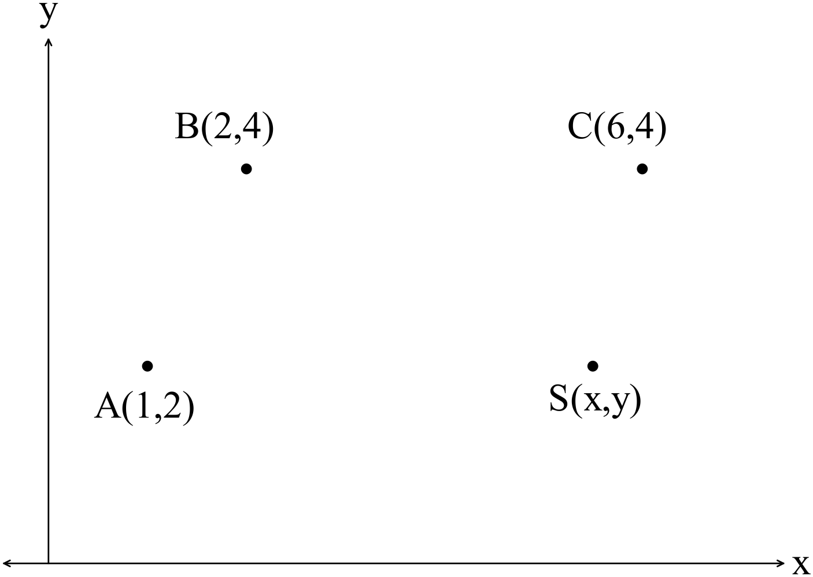

Use a vector method to

(a) find  if $ABCD$ is a parallelogram. (2 marks)

(b) determine the condition(s) required in terms of  so that $ABCD$ is a trapezium. (4 marks)

(c) show that points $A$, $B$ and the origin are collinear. (2 marks)

**Question 6 (11 marks)**

A small boat that can maintain a steady speed of 5 ms-1 is to cross a river from $A$ to $B$, where $\vec{AB}=\left(35i-105j\right) \text{m}$. A current of $\left(-i-2j\right) {\text{ms}}^{-1}$ flows in the river. The velocity vector that the pilot of the small boat must set to travel from $A$ to $B$ is $ai+bj$, where $a$ and $b$ are constants.

1. Explain why $t\left(a-1\right)=35$ and $t\left(b-2\right)=-105$, where $t$ is a constant. (3 marks)
2. Eliminate $t$ from the equations in (a) and hence express $b$ in terms of $a$, simplifying your expression.

(3 marks)

(c) Explain why $a^{2}+b^{2}=25$. (1 mark)

(d) Use your equations from (b) and (c) to determine the values of $a$ and $b$. (3 marks)

(e) Determine the time that the small boat will take to travel from $A$ to $B$. (1 mark)